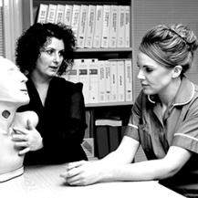
Health and Social Care
Bridging Unit 3
Health, safety and security in health and social care
In Year 12 you will complete a unit health, safety and security in health and social care. This is an externally examined unit. This bridging unit will introduce you to some of the key aspects of this unit and some of the skills you need. If you want to complete your work electronically then you can send it through to dha@hartismere.com and we can provide feedback on it, or alternatively complete the work on paper and bring it with you at the start of Year 12.
Research and provide a definition/explanation for the following key terms.
Hazard
Risk
Legionella bacteria
MRSA
Health and Safety Executive
Hypertension
Immune system
Risk assessment
Manual handling
DBS
Barred list
Safeguarding
Policy
Procedure
Protected time
Induction training
Mandatory training
Briefings
Role
Responsibility
Incident
Accident
Emergency

In this unit you will learn about the different types of hazards in health, social care and child care settings as well as their potential impact on others. You will also learn about the key legislation (laws) and organisational policies and procedures that promote health, safety and security. You will also find out about the roles and responsibilities of employers, employees and individuals who require care and support. Knowing how to respond to different incidents and emergencies will help you to further your understanding of the procedures to follow in health, social care and child care settings. This puts you in a great position when you are applying for university or looking for work as you have already learnt about what will be required in those workplaces and settings.
Health, social care and child care settings can be sources of potential hazards that, if ignored can cause serious problems. It can cause ill health and harm to people as well as damage the environment.
- Can you spot 10 hazards in the below picture?
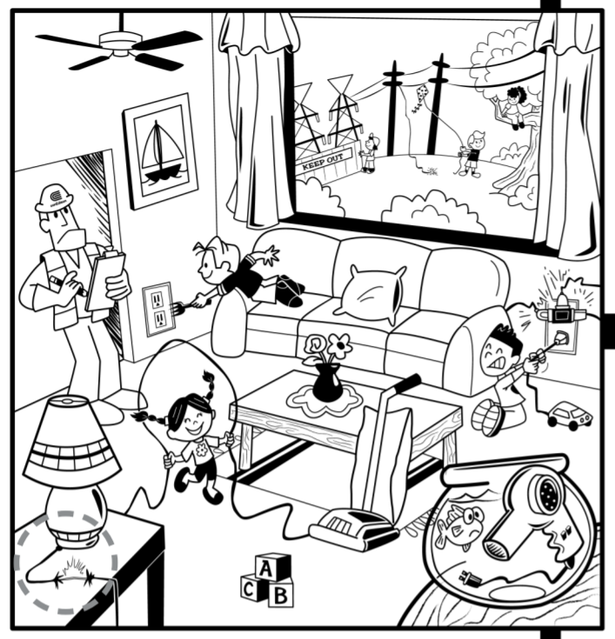
- Research and explain the different hazards in health and social care. Try to give an example for each.
Environmental hazards
Biological hazards
Chemical hazards
Lack of security systems

Psychological hazards

Unsafe working practices

- Choose one of the following settings.
- GP practice
- Hospital ward
- Nursery
- Classroom
Create a floor plan of the setting and include possible hazards. Label and annotate your plan.

- Hazards can have a huge impact on individuals who use services and those who work there.

Case Study
Julie is a community care worker. Every day she visits her client Margaret. Margaret needs help doing things around the house due to her reduced mobility. Whilst there Margaret asks Julie to get something down from on top of her wardrobe. Whilst doing so a large heavy suit case falls from the wardrobe and fractures Julie’s arm.
How would this affect Julie physically?

How would it affect her financially?

What could have been done to prevent this from happening?

- Legislation is in place to make sure that everyone’s safety and security is safeguarded. You need to summarise the following pieces of legislation. Use the links to help you research.
Health and Safety at Work Act 1974
Management of Health and Safety at Work Regulations 1999
Food Safety Act 1990
Manual Handling Operations Regulations 1992
Data Protection Act 1998
Reporting of Injuries, Diseases and Dangerous
Occurrences Regulations (RIDDOR) 2013
Control of Substances Hazardous to Health Regulations (COSHH) 2012

https://www.hse.gov.uk/coshh/basics/index.htm
https://www.hse.gov.uk/healthservices/riddor.htm
https://www.bbc.co.uk/bitesize/guides/z6kj6sg/revision/1
https://www.scie.org.uk/workforce/peoplemanagement/health/healthsafety/
https://www.scie.org.uk/publications/guides/guide15/legislation/otherlegislation/healthandsafetylegislation.asp

- Recommendations to watch/read

- One Born Every Minute
- The Secret Life of 4 Year Olds
- Junior Doctors
- Three Girls
- https://www.youtube.com/watch?v=u63MbY8CCDA
- https://www.youtube.com/watch?v=LprTLaO1AF0
- https://www.youtube.com/watch?v=RlMAYaYRDJE
- https://www.bbc.co.uk/news/10194990
- https://www.nhsconfed.org/news/2018/09/drop-in-mental-health-nurses-shows-nhs-under-severe-strain
- https://www.bbc.co.uk/news/uk-11626806

